Initial project plan:

*“The output from these meetings will form the basis of the documents required at your interim submission. They will include a title for the project, the project vision and the project objectives. The team will also determine what technologies will be used and why.”*

Title for the project:

The project vision:

The project objectives:

Technologies will be used and why:

Frontend:

Backend:

Database: Mysql

Vision control: Github

Product backlog:

example :

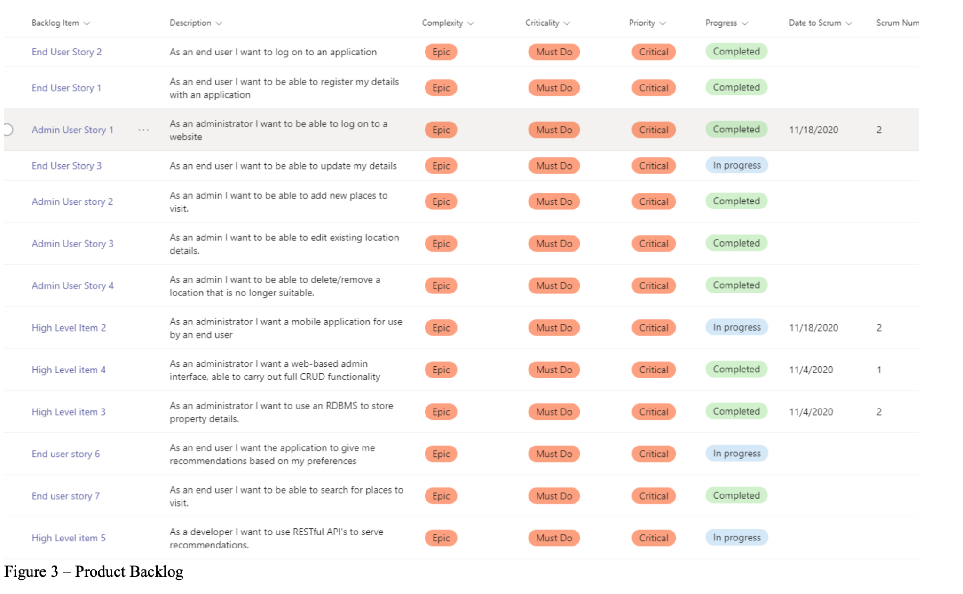

Meeting record:

Group 6 initial meeting

Held between 1900 and 2000 hours on 2022-11-09 (Wed)

Client Aims:

* Introduce different natural species like bird or tree.
* Encourage public to join the event or activity like counting the specific species for special day in order to let people to recognize various species (Some species can only be found in HK).

Client Requirements:

* Develop an easy system to submit the records like EBIRDS or HKBWS website which can provide the below simple functions:
* View the last submission if client has submitted.
* The records should be including the incident datetime and location, the number of species (e.g. bird or tree or butterfly), the descriptions of the birds’ behaviour or the observation of the tree (such as damaged?).
* Few buttons on the system, client focus on jotting down the notes so it just needs taking photo and then uploading it to the system for saving time
* The system provides a flexible platform to easily switch different home pages for different species, no one app for one species.
* It should be banned when submitting something invalid photo or documents (Security problem concern).
* Client concerns the graphic or data which might be stolen, so it should have the watermark or other possible/feasible protection) like HK WILDTRACKS.
* Language: English and traditional Chinese
* It maybe has a list to customize for species, updating the species names.
* Provide a standard list of species items for user input.
* Admin can verify the submission of the records.
* Focus on the mobile phone devices and support the TSV format at least.